Linkage Mapper Toolbox:
Linkage Pathways Tool User Guide
Version 3.0—Updated July 2021

Brad McRae¹ and Darren Kavanagh²
¹The Nature Conservancy
²Adze Informatics

Acknowledgements
Brian Cosentino made substantial coding contributions to early versions of this toolbox. Viral Shah contributed code from his thesis for network analyses. Jeff Jenness supported this work with updates to the Conefor Inputs tool. Thanks to Andrew Gilmer and Theresa Nogeire for helpful comments on this user guide. Thanks also to the Washington Habitat Connectivity Working Group for feedback on these tools as they were being developed. John Gallo and Randal Greene made minor changes such as terminology and screengrab updates for the v2.0 Release.

Software Requirements and Licensing
Linkage Mapper requires ArcGIS Desktop (10.3 or greater) or ArcGIS Pro, with the ArcGIS Spatial Analyst extension. If you are using ArcGIS Desktop and do not have an Advanced license, you will also need to install the Conefor Inputs tool (see below). Linkage Mapper is provided free of charge and is licensed under a GNU General Public License.

Preferred Citation
McRae, B.H. and D.M. Kavanagh. 2011. Linkage Mapper Connectivity Analysis Software. The Nature Conservancy, Seattle WA. Available at: https://circuitscape.org/linkagemapper.

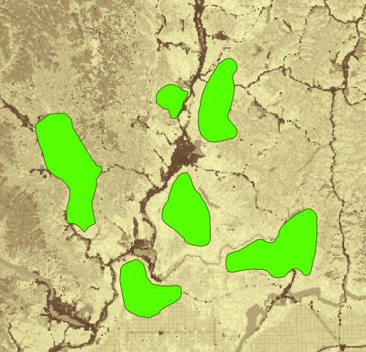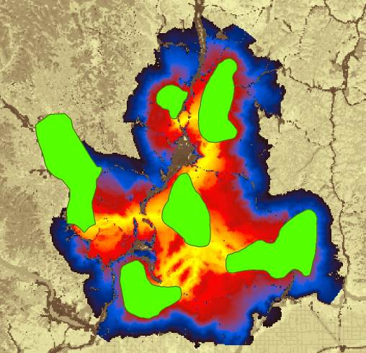
Table of Contents
1. Introduction 3
1.1 Background 3
1.2 Before you begin– a note about connectivity modeling and software limitations 3
2 Installation 4
3 Using Linkage Pathways 5
3.1 Input data requirements 5
3.2 Prepping your data and work spaces 5
3.3 Running the toolbox 7
4 What the Steps Do 10
Step 1: Identify adjacent (neighboring) core areas 11
Step 2: Construct a network of core areas using adjacency and distance data 11
Step 3: Calculate cost-weighted distances and least-cost paths 12
Step 4: Implement optional rules specifying which core area to connect 14
Step 5: Calculate least-cost corridors and mosaic them into a single map 14
5 Other features, extra hints, and troubleshooting 16
5.1 Saving and re-loading run settings 16
5.2 Scaling your resistance values 16
5.3 Applying Linkage Pathways to large study areas, large core areas, or large numbers of core areas 16
5.4 Manually removing or retaining links 16
5.5 Freeing up disk space 16
5.6 Combining Linkage Pathways and Circuitscape to prioritize connectivity conservation 17
5.7 Common problems 17
5.8 Recovering if ArcGIS applications crash in Step 3 17
5.9 Helpful utilities and accessing additional options 18
5.10 Upgrading 18
6 Community 18
7 Literature Cited 18
8 Linkage Pathways Tutorial 19

Introduction

Background
The Linkage Pathways Tool of the Linkage Mapper Toolbox is a GIS tool designed to support regional wildlife habitat connectivity analyses. It consists of several Python scripts, packaged as an ArcGIS tool, that automate the mapping of wildlife habitat corridors.
Linkage Pathways uses vector maps of core habitat areas and raster maps of resistance to movement to identify and map least-cost linkages between core areas. Each cell in a resistance map is attributed with a value reflecting the energetic cost, difficulty, or mortality risk of moving across that cell. Resistance values are typically determined by cell characteristics, such as land cover or housing density, combined with species-specific landscape resistance models. As animals move away from specific core areas, cost-weighted distance analyses produce maps of total movement resistance accumulated.
The scripts use ArcGIS and Python functions to identify adjacent (neighboring) core areas and create maps of least-cost corridors between them. The scripts then normalize and mosaic the individual corridor maps to create a single composite corridor map. The result shows the relative value of each grid cell in providing connectivity between core areas, allowing users to identify which routes encounter more or fewer features that facilitate or impede movement between core areas.
We developed these scripts to support the 2010 Washington Wildlife Habitat Connectivity Working Group (WHCWG) statewide connectivity analysis, and public them public for use in other wildlife connectivity assessments. More details on the models and algorithms implemented by Linkage Pathways can be found in Chapter 2 and Appendix D of WHCWG (2010).
Enhanced Modules–The toolbox now includes newly developed tools to map pinch-points within corridors (using Circuitscape) , map core areas and corridors with high network centrality (i.e. those that are most important for keeping a network connected), map barriers (some of which may offer restoration opportunities), the relative priority among all the linkages on a landscape, and map corridors that follow climatic gradients to facilitate species range shifts in response to climate change. Please see the Pinchpoint Mapper, Centrality Mapper, Barrier Mapper, Linkage Priority, and Climate Linkage Mapper user guides included with the Linkage Mapper download.

Before you begin– a note about connectivity modeling and software limitations
Linkage Pathways was developed to automate some of the arduous and time-consuming steps of connectivity modeling. However, even with tools like this one, connectivity modeling involves a great deal of research, data compilation, GIS analyses, and careful interpretation of results. Defining core areas, parameterizing resistance models, and other modeling decisions you will need to make are not trivial. Before diving in, we strongly recommend that users thoroughly familiarize themselves with the process and challenges of connectivity modeling by consulting published resources. Good places to start include an overview of habitat and corridor modeling on the Corridor Designer website (http://corridordesign.org/designing_corridors), WHCWG (2010), Beier et al. (2011), and references listed within. See Sawyer et al. (2011) for a critique of current corridor modeling practices.

You can see WHCWG (2010) for the kind of datasets for which Linkage Pathways was developed and tested. You may encounter bugs or limitations applying it different datasets, especially study areas with large numbers of grid cells, large numbers of core areas, or core areas with highly complex shape.

Installation
- Make sure you have the required GIS and Python installations
Linkage mapper requires ArcGIS Desktop (10.3 or greater) or ArcGIS Pro, with ArcGIS Spatial Analyst. You will also need Python and NumPy (Numerical Python), which are automatically installed by ArcGIS.

- Install Linkage Mapper
Download Linkage Mapper from https://circuitscape.org/linkagemapper.
Open the linkagemapper.zip archive and place the contents in a folder that has no spaces or special characters in its path (e.g. C:\LinkageMapper).

- Install the Conefor Inputs Tool for ArcGIS (optional for users with ArcGIS Desktop
Advanced or ArcGIS Pro)
Download Conefor inputs from: http://jennessent.com/arcgis/conefor_inputs.htm. Once you’ve downloaded the tool, follow the instructions in the Conefor Inputs user guide. From there, you’ll need to activate the Conefor toolbar in ArcMap: View>>Toolbars>>Conefor. The toolbar should look like this:

- Verify your installation
There are multiple ways to access the Linkage Mapper toolbox in ArcGIS. The simplest method is to browse to the installation directory via a catalog folder connection and double clicking the toolbox. For other methods see the product help.

You can test the code by running the tutorial at the end of this document.

Using Linkage Pathways

Input data requirements
Inputs to Linkage Pathways include 1) a core area polygon GIS file, 2) a resistance raster GIS file, and, depending on your ArcGIS software or license, 3) a text file specifying Euclidean (straight-line, edge-to-edge) distances between core area polygons. The core area polygon GIS file can be either an ESRI shapefile or ESRI geodatabase feature class. The file must have an attribute specifying core area IDs consisting of positive integers < 9999 that identify unique core areas. The resistance raster GIS file should include resistances represented by positive numbers (integers or floating point) only. We recommend resistances scaled so that values of 1 represent ideal habitat (WHCWG 2010) and increase to at least 100 for barriers (Beier et al. 2011).

Please ensure that your resistance and core area maps are in the same projection. Linkage Pathways has not been tested with data in different coordinate systems. We strongly suggest that map units be in meters.
The text file with Euclidean distances between cores can be generated by the Conefor Inputs tool using the core area file as input (see next section). It can also be automatically generated by Linkage Pathways if you have ArcGIS Desktop Advanced or ArcGIS Pro.

Prepping your data and work spaces
Before you start, you’ll need to set up your project directory and, if necessary, create a Euclidean distances file using your core area polygon data and the Conefor Inputs Tool.
1) Create a project directory
This is where intermediate and output files will be written. This should be a shallow and short directory (something like C:\ANBO), ideally on a local drive to speed processing. The name of the directory will also be used as a prefix for final output files (e.g. ANBO_LCPs). There should be no spaces or special characters anywhere in the directory path.
Note: running Linkage Pathways with input data or project directories on a shared drive can slow things down drastically, and can cause errors with some ArcGIS routines. It’s best to use a local drive (and shallow directory) if you can.


You should create unique project directories for each project/scenario you run, to avoid confusing intermediate data from different analyses.

Several subdirectories will be created in your project directory, including an output directory with final products. Data are passed between computational steps in the datapass directory. The scripts also create vector line maps with corridor statistics (stored in the datapass directory between steps and the link_maps geodatabase in the output directory when the program completes), as well as raster corridor maps (stored in the corridors geodatabase). Step-by-step versions of link maps are moved to run_history directory after completion. This directory also has a log directory where run messages are stored.
2) If you don’t have an Advanced ArcGIS Desktop license or ArcGIS Pro, calculate Euclidean (straight-line) distances between core areas using the Conefor Inputs Tool.
The Conefor Inputs Tool measures minimum Euclidean distances between core area polygons. We use this tool solely to generate a text table of core area pairs and distances between them. If you have another way to provide a table of distances in the same format (see the demo data provided in the tutorial), you may do that instead.
Conefor Inputs gives you the option to analyze either all core area pairs or only those within a specified distance. Restricting analyses to a specified distance is particularly useful when working with large numbers of core areas for a specific species; if a species is only known to disperse X map units, and you want to only map linkages that are less than X in length, then using this cutoff can save calculation time if you have hundreds or thousands of core areas.
Don’t forget: if you modify your core polygon layer, be sure to re-run Conefor Inputs with the new data.
Start by clicking on the left toolbar button

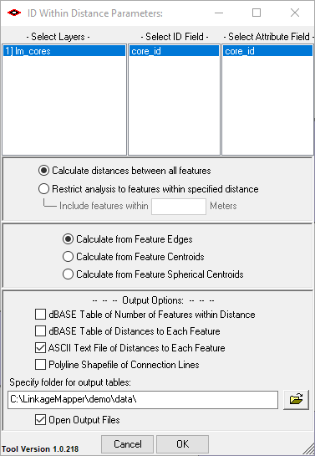
This window should appear.
- Select your core area polygon file in the Layers column. Then, select a unique core area ID field in the ID and Attribute field columns.
- Choose whether to calculate distances between all features or restrict your analyses to features within a specified distance (see above).
Note: If you restrict analyses to features within a specified distance, be sure to enter distances using the same units of measurement that are used in your GIS files.
- Select the option to calculate distances from the edges of features.
- Have Conefor Inputs create an output file in text format by selecting ASCII.
- Select a location to save the output file. You’ll need to browse to this file again later.
- Click OK (Conefor may give you an error, but you can ignore it as long as you get a distance table in your output folder).
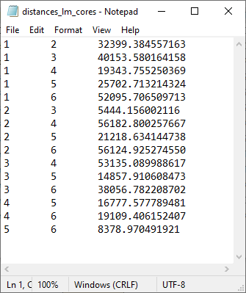
Text file created by Conefor Inputs showing Euclidean distances between core areas.

Running the toolbox
Note: ArcGIS can maintain file locks even with it is done with a file. If you get schema lock or permission errors, you may need to close ArcGIS applications and start fresh without any output files displayed.

Note: Several ArcGIS Desktop users have reported that they experience fewer ArcGIS errors when running from ArcCatalog. We therefore suggest you run from ArcCatalog if you are having problems with the tool in ArcMap.
Click the Linkage Pathways Tool toolset of the Linkage Mapper toolbox, and click on Build Network and Map Linkages. The following dialog should appear in ArcGIS Desktop. Lettered items are described below.

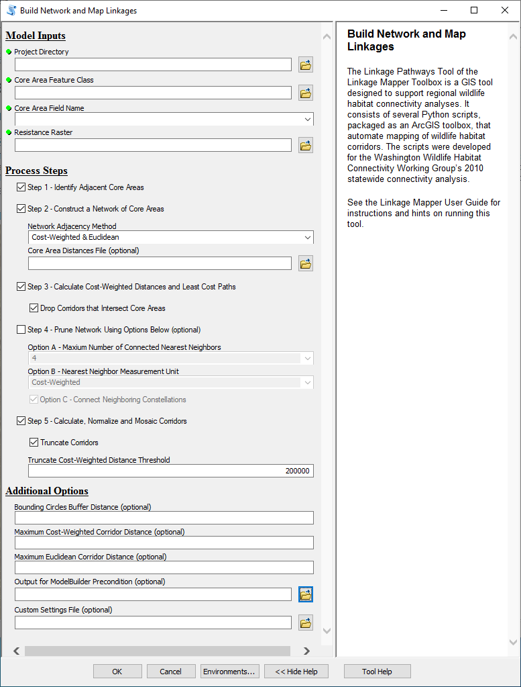
A
B
C
D
E
F
H
G

- Input Data
  - Project Directory: Enter the project directory for your analyses (described in section 3.2 above). You should create a different project directory for each unique project/scenario you run, to avoid confusing data from different analyses.
  - Core Area Feature Class: This is your map of core habitat area polygons (the polygons you will be connecting with linkages).
Note: if you choose a feature class that is open in a map and any of the features are selected, Linkage Pathways will only operate on those features.
  - Core Area Field Name: Field must consist of positive integers < 9999 that identify unique core areas in your core area polygon file.
  - Resistance Raster: Enter the resistance raster for your project.
- Check the steps you want to complete. You can check all steps to run from start to finish in one shot. You can also re-start failed or killed runs at any step in the process by checking only those steps you want to re-do. Note: Step 4 is optional. Check step 4 and fill in step 4 options if you want to only connect each core to its 1-4 nearest neighbors and then connect clusters of cores together, rather than connecting all adjacent cores. Refer to Section 4 below for more details on what each step does.
- Step 1 - Identify Adjacent (neighboring) Core Areas
- Step 2 - Construct a Network of Core Areas
  - Network Adjacency Method: Specify whether to create links between core areas that are adjacent in Euclidean and/or cost-weighted distance space. If you choose both, corridors will be mapped between core areas that are adjacent in Euclidean OR cost-weighted distance space.
  - Core Area Distances Text File: Enter the distances text file generated by the Conefor Inputs tool (users with ArcGIS Desktop Advanced or ArcGIS Pro can leave the field blank and have Linkage Pathways create this file. This can be time consuming, so if you are re-running with the same core file, make sure to point to the text file Linkage Pathways created earlier (ending in “dists.txt”), which can be found in your project directory).
- Step 3 - Calculate Cost-Weighted Distances and Least-Cost Paths
  - Drop Corridors that Intersect Core Areas: This will take effect in step 3. See detailed description in Section 4 below.
- Step 4 - Prune Network
You can limit the number of corridors mapped to those needed to ensure that each core area is connected to its 1-4 nearest neighbors (and then optionally connect any disjunct ‘constellations’ of core areas below).
Number of Connected Nearest Neighbors: If step 4 is checked, this option lets you choose how many nearest neighbors to connect each core area to. Any links that are not needed to connect each core to its N nearest neighbors are dropped. Selecting “Unlimited” allows connections to all neighbors.
Nearest Neighbor Measurement Unit: Choose whether to measure ‘nearest’ above in Euclidean or cost-weighted distance.
Connect Neighboring Constellations: After links that are not needed to connect each core to its N nearest neighbors are dropped, this option allows you to re-add links connecting nearest pairs of core area ‘constellations,’ i.e., discrete clusters of neighboring core areas, until all constellations are connected.
- Step 5: Calculate, Normalize, and Mosaic Corridors
  - Truncate Corridors: When checked, create a copy of the project_corridors output, with cost-weighted distance values above the threshold value specified below converted to NoData.
  - Truncate Cost-Weighted Distance Threshold: The threshold to use with the Truncate Corridors option above.
- Additional Options:
  - Bounding Circles Buffer Distance (optional): If a value is entered, this will create bounding circles around pairs of core areas (recommended for speed; see detailed description in Section 4 below). Buffer distances are entered in map units, e.g. a 10 km buffer would be entered as 10000 if map units were in meters. Leave blank if you don’t want to use bounding circles.
  - Maximum Corridor Distances: Maximum distances can speed up calculations by dropping excessively long corridors. If you are unsure, you should leave blank or overestimate. You can always make distances more stringent by re-running step 5. You can’t make them less stringent without going back to step 2.
    - Maximum Cost-Weighted Corridor Distance (optional): If you only want to map corridors that are less than a maximum cost-weighted corridor length, enter it here (in map units). This will take effect in steps 3-5.
    - Maximum Euclidean Corridor Distance (optional): If you only want to map corridors between core areas that are closer than a certain distance apart, enter it here (in map units). This will take effect in steps 2-5. NOTE: least-cost corridors can still be longer than this distance, as they will typically be considerably longer than the edge-to-edge distance between the core pairs they are connecting.
  - Output for ModelBuilder Precondition (optional): Create an optional output copy of the input cores, which can be used in ModelBuilder workflows to indicate that LP has finished processing.
  - Custom Settings File (optional): An optional .py file to be used in place of lm_settings.py, which facilitates keeping all the settings needed to reproduce a scenario run.

What the Steps Do
- As described above, the Build Network and Map Linkages tool takes 1) a core area polygon map, 2) a resistance raster, and 3) a text file specifying Euclidean distances between core area polygons (if you have ArcGIS Desktop Advanced or ArcGIS Pro Linkage Pathways will generate this automatically). The tool then processes these data in 5 steps, illustrated and described below:

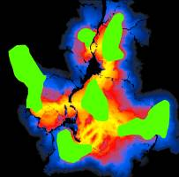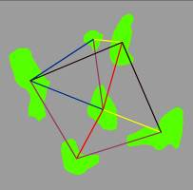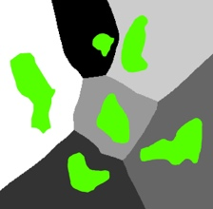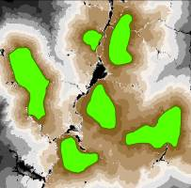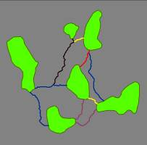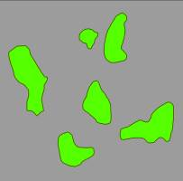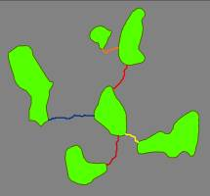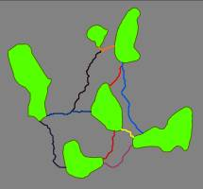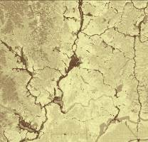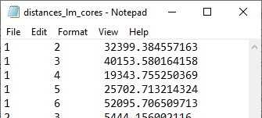
Resistance
raster
Step 1: Identify
adjacent (neighboring)
core areas

Step 5: Calculate least-cost corridors and mosaic them into a single map

Step 4 (Optional): Implement additional rules specifying which core areas to connect

Step 3: Calculate cost-weighted distances and least-cost paths

Step 2: Construct a network of core areas using adjacency and distance data

Text file of distances
between core areas
Map of core areas to connect

Step 1: Identify adjacent (neighboring) core areas
Inputs: core area polygon file and resistance raster file.
Outputs: text files listing adjacent core areas in Euclidean (straight-line) and cost-weighted distance space (euc_adj.csv and cwd_adj.csv).
Step 1 identifies adjacent core areas using the ArcGIS Cost Allocation and Euclidean Allocation functions. Using your core area polygons and resistance raster, ArcGIS creates raster files that ‘allocate’ grid cells to the nearest core area in either Euclidean space or cost-weighted distance space. If a pathway from one core area to another must pass through the allocation zone of a third, then the two core areas are considered nonadjacent. For example, core areas 1 and 6 below are not adjacent because it is impossible to move from one to the other without at least passing through the allocation zone of core areas 2, 4, or 5. This step creates a subdirectory named ‘adj’ within your project directory and stores rasters with data on adjacency and distances there. Adjacency lists are stored in text files euc_adj.csv and cwd_adj.csv within your datapass directory.

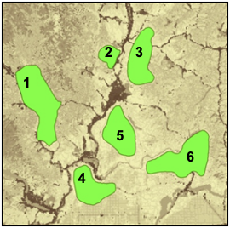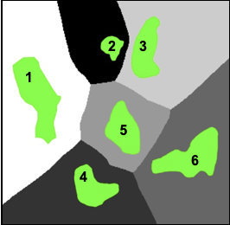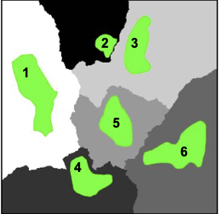
Core areas, resistance surface, and allocation grids for Linkage Pathways tutorial data. Left: core areas (green) and resistance surface (lower resistances shown in lighter shades). Center: Euclidean allocation zones, with different shades for each core area. Right: cost-weighted distance allocation zones. In this example, core areas 1 and 3 are adjacent in cost-weighted distance space, but not in Euclidean space.

Step 2: Construct a network of core areas using adjacency and distance data
Inputs: core area polygon file, text file of distances produced by Conefor Inputs (or Linkage Pathways), and core area adjacency files (euc_adj.csv and/or cwd_adj.csv).
Outputs: text file describing network (linkTable_s2.csv), and stick map showing links (sticks_s2.shp).
This step recognizes the text files specifying core area adjacency (euc_adj.csv and cwd_adj.csv) created in step 1, as well as the distances calculated using the Conefor Inputs tool or Linkage Pathways. It uses these to create a “stick map” (sticks_s2.shp) connecting core area pairs that are candidates for corridor mapping. This step also generates linkTable_s2.csv, a table viewable in Microsoft Excel. This table describes the network and keeps track of which links are active, which are dropped, and statistics on each. These files are all stored in your datapass directory, and are used and updated with new versions (linktable_s3.csv, etc.) in subsequent steps. They are also saved in your run_history directory for reference. This step allows you to automatically discard links that are longer than a specified maximum Euclidean distance.
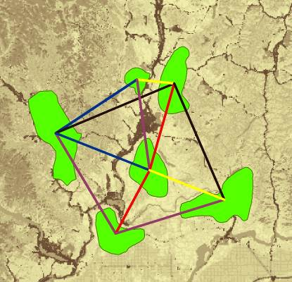“Stick Map” created in step 2 (stored in run_history directory as sticks_s2.shp). Stick numbers show potential links between adjacent core areas, and include information on each. In this example, stick colors correspond to Euclidean (straight-line) distances between polygon edges.
Euclidean
distance
5 km

40 km

Step 3: Calculate cost-weighted distances and least-cost paths
Inputs: core area polygon file, resistance raster file, linkTable_s2.csv.
Outputs: cost-weighted distance rasters for each core area (stored in cwd directory), a single cost-weighted distance raster for all core areas (cwd, stored in the output directory), linkTable_s3.csv, sticks_s3.csv, lcplines_s3.csv.
Step 3 uses the core area polygons, resistance raster, and link table from step 2 to perform cost-weighted distance calculations from each core area. As each cost-weighted distance surface is created, Linkage Pathways also extracts minimum cost-weighted distances between source and target core area pairs.
Step 3 also maps least-cost paths (the route along which the least resistance is accumulated) from core to core, using the cost-weighted distance raster and a direction raster for each core area. This step allows users to automatically discard linkages where the least-cost path passes through an intermediate core area (see graphic below) or linkages that are longer than a specified maximum cost-weighted or Euclidean distance.

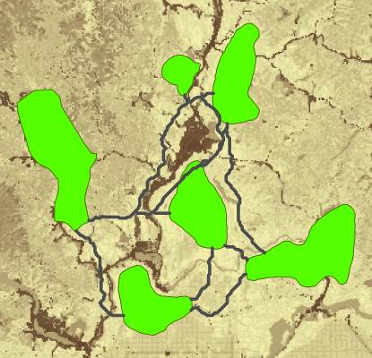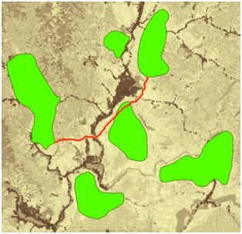
Least-cost paths between adjacent core areas (left). The red path (right) passes through an intermediate core area- that link would be dropped if the Drop Corridors that Intersect Core Areas box were checked. Links that are too long in Euclidean or cost-weighted distance can also be dropped automatically.

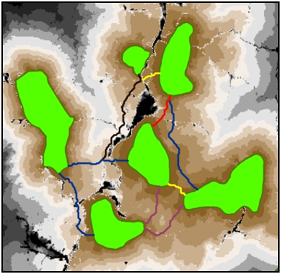
Cost-weighted
distance to
nearest core area

0 km

28,000 km
Cost-weighted
corridor length
14 km

118 km
Step 3 places cwd, a raster showing the cost-weighted distance to the nearest core area, in the output directory. Least-cost path lines are attributed with various linkage statistics (e.g. the total cost-weighted distance traversed by the linkage, shown above).

Minimizing processing time using the bounding circles option
Using bounding circles can considerably speed up calculations. Linkage Pathways first calculates bounding circles around “source” and “target” core area pairs. The resistance layer is then clipped by the union of all bounding circles for the source core area plus a buffer large enough to allow corridors sufficient room to “roam.” For example, the graphic below shows buffer distances of 10 km (entered as 10000 map units under the Buffer Distance for Bounding Circles in the Additional Options section of the toolbox). This limits cost-weighted distance calculations from each source core to include only the portion of the landscape likely to be relevant to connectivity between the sources and target cores, reducing processing time.

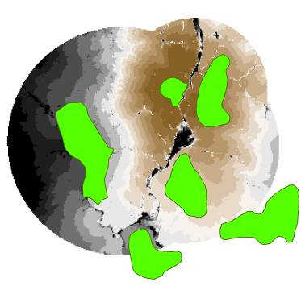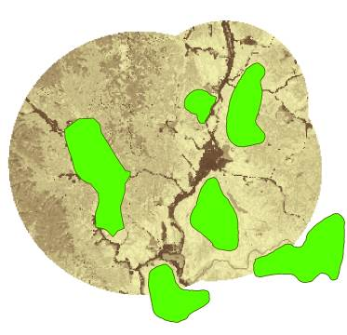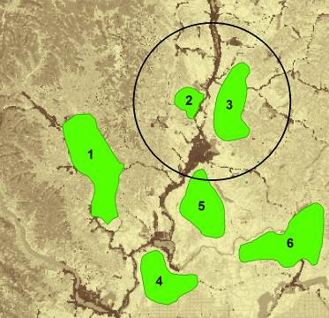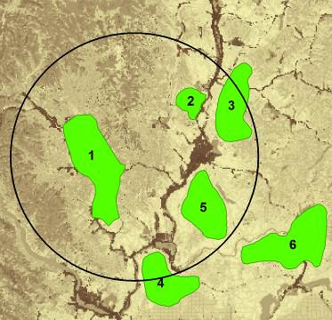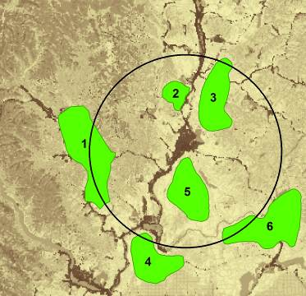
Cost-weighted
distance to
core area #2

0 km

28,000 km
Bounding circles calculated for core area 2. Top: circles encompass core area 2 and each respective ‘target’ core area (1, 3, and 5) plus a buffer distance. Bottom left: for cost-weighted distance calculations from any core area, the algorithm extracts the portion of the resistance layer that falls within the union of all circles containing that core area. Bottom right: cost-weighted distance calculated from core area 2.
Note: If you’re unsure of an appropriate buffer distance, we recommend using a large value or skipping entirely. However, be aware that for large datasets with hundreds of core areas, the processing time can add up fast.

Step 4: Implement optional rules specifying which core area to connect
Inputs: linkTable_s3.csv, lcplines_s3.shp.
Outputs: linkTable_s4.csv, sticks_s4.shp, lcplines_s4.shp.
Step 4 optionally lets you connect each core area to just its 1-4 nearest neighbors, and then connect disjunct clusters (constellations) if desired. The latter will connect clusters of core areas together, starting with the closest, until all clusters are connected (as long as they are within maximum corridor lengths, if specified). You can measure ‘nearest’ in either Euclidean or cost-weighted distance.
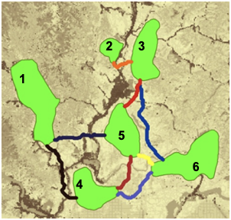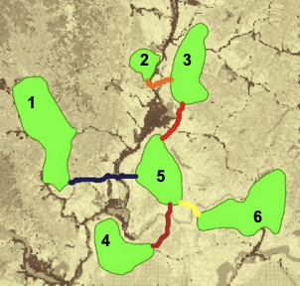
Cost-weighted
corridor length
14 km

76 km
Here’s how step 4 alters the network when run with the option to connect each core area to its nearest neighbor (Step 4 option A = 1) in cost-weighted distance units and then connect disjunct constellations (Step 4 option C). In this case, two constellations were formed, with the two northernmost cores constituting one constellation and the remaining four cores constituting the other. The link between core areas 3 and 5 then connected the two constellations to form a single, connected network.

Step 5: Calculate least-cost corridors and mosaic them into a single map
Inputs: linkTable_s4.csv or linkTable_s3.csv; cost-weighted distance rasters; lcplines_s4.shp (if present in datapass directory) or lcplines_s3.shp.
Outputs: Final products including linkTable_s5.csv, (stored in the output directory), and final linkage maps and least-cost path feature classes (stored in corridors.gdb and link_maps.gdb in the output directory).
Step 5 calculates least-cost corridors (the sum of cost-weighted distance rasters calculated from each pair of core areas that are connected). It also normalizes least-cost-corridors by subtracting the least-cost path distance from the raw corridor:
NLCC_{AB} = CWD_{A} + CWD_{B} – LCD_{AB}
Where NLCC_{AB} is the normalized least cost corridor connecting core areas A and B, CWD_{A} is the cost-weighted distance from core area A, CWD_{B} is the cost-weighted distance from core area B, and LCD_{AB} is the cost-weighted distance accumulated moving along the ideal (least-cost) path connecting the core area pair. This step maps all corridors in the same ‘currency;’ grid cells in each normalized corridor raster range in value from 0 (the best or least-cost path) on up. Cell values are still in cost distance units, and reflect how much more costly the (locally optimal) path between the core areas passing through each cell is relative to the (globally optimal) least-cost path connecting the core area pair. As it calculates normalized corridors, step 5 combines them into a single map using the ArcGIS Mosaic function to create a composite linkage map in which each cell represents the minimum value of all individual normalized corridor layers.

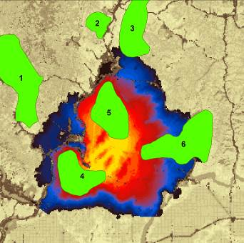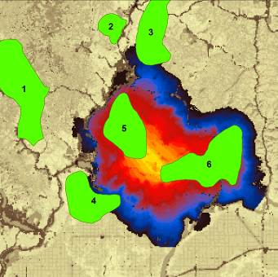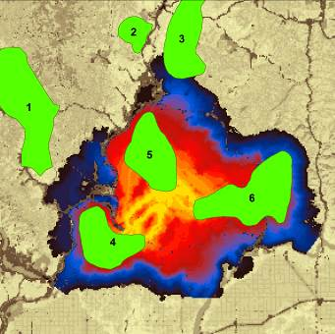
Normalized least-
cost corridor
distance
0 km

100 km
Compositing process for normalized least-cost corridors. Panels show just two corridors as an example. Left and center panels show normalized least-cost corridors connecting core area 4 to core areas 5 and 6, respectively. Colors indicate how much more costly the route between core area pairs passing through each cell is relative to the least-cost path connecting the core area pair. Linkage Pathways takes the minimum value of all normalized corridors to create a composite map (right panel).

This step also writes final stick and LCP maps, separated into active and inactive sticks and LCPs. Inactive links are those that have been dropped based on user criteria. It creates a final link table that only includes active links. Final link tables have extra columns with additional info, including lcpLength (the un-weighted length of the least-cost path), cwdToEucRatio (the ratio of cost-weighted distance to Euclidean distance between core areas), and cwdToPathRatio (the ratio of cost-weighted distance to the un-weighted length of the least-cost path, i.e. the distance traveled moving along the path). Finally, this step creates geodatabase (link_maps.gdb and corridors.gdb) in the output directory with final LCP and stick feature classes and mosaicked least-cost corridor maps.

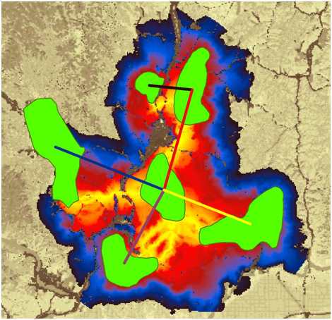
Cost-weighted
to Euclidean
distance ratio
1.65

3.43
Normalized least-
cost corridor
distance
0 km

100 km
Normalized and mosaicked least cost corridors using the tutorial data (saved in corridors.gdb). Yellow grid cells are closer to corridor centers, with dark blue cells showing routes that accumulate up to 100km cost-weighted distance more than the optimal (least-cost) route. Stick colors show the ratio of cost-weighted distance to Euclidean distance for each link (cwd2Euc_r field in the feature classes), a metric of corridor quality. Yellow sticks show linkages that accumulate the least cost per unit Euclidean distance between core areas, while black sticks show linkages that accumulate the most.

Other features, extra hints, and troubleshooting

Saving and re-loading run settings
ArcGIS automatically saves settings from previous runs, and you can re-load them using the Results tab. See the relevant ArcGIS application help for instructions. You can pick up a failed run (or re-run starting from any step using different parameter choices) by un-checking the steps prior to the one you wish to start at. No need to delete output files; they will be automatically overwritten.

Scaling your resistance values
Creating resistance and core area maps is the trickiest part of connectivity analysis, and methods for doing this is beyond the scope of this manual. However, you’ll find that it’s a good idea to set lowest resistances to 1: that way the cost-weighted distance of moving through ‘ideal’ habitat is equal to Euclidean distance moved, and linkage statistics become more meaningful because they can be compared against values that would be expected in a fully connected landscape. We typically recommend maximum resistances of at least 100, and users often go to 1,000 or 10,000.

Applying Linkage Pathways to large study areas, large core areas, or large numbers of core areas
Before applying Linkage Pathways to a large project or study area, we recommend testing on a small area with a limited number of core areas. This will help you get a feel for how Linkage Pathways works, and for which parameter combinations will give you results that best meet your objectives. Please note that large core areas can cause Linkage Pathways to take take hours, or even days, to calculate Euclidean distances in step 2. This is a limitation of the ArcGIS GenerateNearTable algorithm, which we use to calculate distances between core areas.

Manually removing or retaining links
Links can be manually removed by editing one of the linkTable files in the datapass directory. For example, to remove a link before step 4 runs, edit linkTable_s3.csv and set the value for the link in the ‘linkType’ column to -100. Then run Linkage Pathways starting at step 4 by only checking Steps 4 and 5. Links with negative linkType values are automatically discarded, and -100 is reserved for user-removed links.

To keep a link that would otherwise be dropped because of its Euclidean or cost-weighted length, first run Linkage Pathways through step 3 without using a maximum distance. Then edit linkTable_s3.csv and set the value for the link in the ‘linkType’ column to 100. You can then apply maximum distances and they will be ignored for that link.

Freeing up disk space
Linkage Pathways creates cost-weighted distance rasters for every core area. This can take up very large amounts of disk space. To free up disk space once you are satisfied with final results, you can delete the cwd folder in your datapass directory (the Delete CWD Rasters utility will do this for you). Once it’s deleted, you will need to re-run step 3 if you want to generate new corridors with modified input settings.

Combining Linkage Pathways and Circuitscape to prioritize connectivity conservation
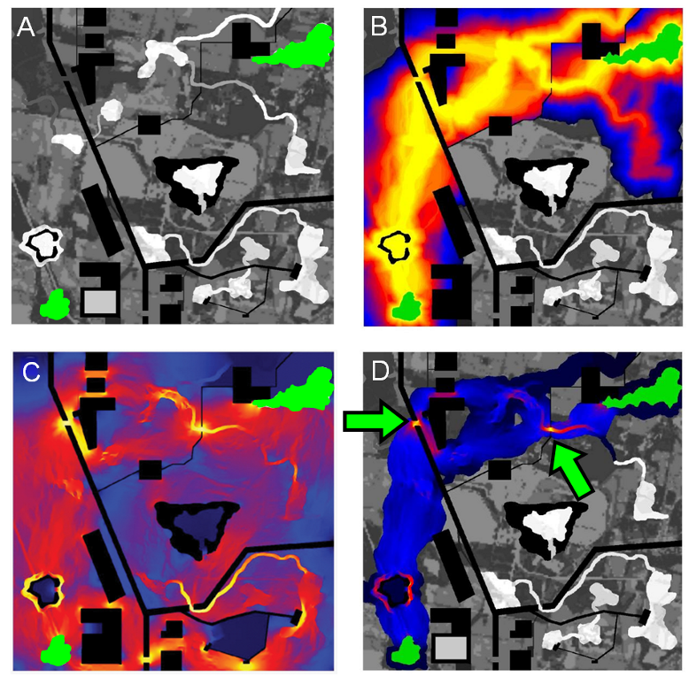
Circuit theory can complement least-cost analyses and help to prioritize important areas for connectivity conservation (McRae et al. 2008). The Pinchpoint Mapper tool will automatically run Circuitscape within Linkage Pathways outputs to get the best of both approaches, as illustrated below (see the Pinchpoint Mapper user guide included with the Linkage Mapper download).
Example of how circuit theory can be used to identify and prioritize important areas for connectivity conservation. (A) Simple landscape, with two patches to be connected (green) separated by a matrix with varying resistance to dispersal (low resistance in white, higher resistance in darker shades, and complete barriers in black). (B) Least-cost corridor between the patches (lowest resistance routes in yellow, highest in blue). (C) Current flow between the same two patches derived using Circuitscape (McRae and Shah 2009), with highest current densities shown in yellow (from McRae et al. 2008). Circuit analyses complement least-cost path results by identifying important alternative pathways and “pinch points,” where loss of a small area could disproportionately compromise connectivity. (D) A promising application is restricting circuit analyses to least-cost corridor slices to take advantage of the strengths of both approaches. This hybrid approach shows both the most efficient movement pathways and critical pinch points within them, which glow yellow. These could be prioritized over areas that contribute little to connectivity, such as the dark blue “corridor to nowhere” at the top right.

Common problems
Some programs can conflict with ArcGIS and cause errors. Antivirus software often causes problems (we’ve seen problems with AVG in particular). Writing to Dropbox folders causes errors too. Apparently, these programs try to access files at the same time ArcGIS does, and they don’t get along. Disabling antivirus temporarily and pausing Dropbox syncing can solve these problems.

Recovering if ArcGIS applications crash in Step 3
ArcGIS applications can cause crashes in Step 3 on some installations when processing large numbers of core areas.
To restart where Linkage Pathways left off in step 3 (but see warning below):
1) Check step 2.
2) Enter 'restart' (no quotes, just the word restart) in the Core Area Distances file box.
3) Uncheck step 2 (and step 1 if it was checked). Make sure step 3 is checked.
4) Hit run. Linkage Pathways should pick up where it left off.

Warning: You should only use this if you want to quickly get a corridor map because your LCP and stick feature classes will lose LCPs that were created before the tool left off. But your final raster corridor map should be complete. If possible, we recommend re-running from the beginning of step 3 (not using the ‘restart’ function) and taking steps to avoid ArcGIS errors.

Helpful utilities and accessing additional options
See the Utilities toolset for tools to clip corridors to desired widths, coarsen resistance rasters, and remove temporary CWD files that take up a lot of space once you are done with corridor mapping.These utilities don’t have separate documentation. Click ‘Show help’ in the toolbox dialog for explanations of the different inputs and settings.

Once you are familiar with Linkage Pathways, you can change some settings, such default corridor widths or whether to use minimum distances between core areas, by editing lm_settings.py (located in your toolbox/scripts directory).

Upgrading
For those upgrading to version 3 from earlier versions of LM, please consider the following:
- If you want your old projects to automatically use the new LM and LP, install the toolbox in the same location as the previous version.
- Due to the addition of new LM parameters in the LM tool dialog, running LM from geoprocessing results history will result in “ERROR 000820 The parameters need repair”. To overcome this issue, run LM from the toolbox, not from the geoprocessing history.
- ModelBuilder models that call LM will need to be edited, re-validated and saved.

Community
Please join the Linkage Mapper Google Groups forum at https://groups.google.com/g/linkage-mapper to get updates, report bugs, and suggest enhancements. Please also visit the project website at https://circuitscape.org/linkagemapper/.
To contribute to the development of Linkage Mapper explore our code repository on GitHub: https://github.com/linkagescape/linkage-mapper.

Literature Cited
Beier, P., W. Spencer, R. Baldwin, and B.H. McRae. 2011. Best science practices for developing regional connectivity maps. Conservation Biology.
McRae, B.H., B.G. Dickson, T.H. Keitt, and V.B. Shah. 2008. Using circuit theory to model connectivity in ecology, evolution, and conservation. Ecology 10: 2712-2724.
McRae, B.H., and Shah, V.B. 2009. Circuitscape User’s Guide. ONLINE. The University of California, Santa Barbara. Available at: https://circuitscape.org.
Sawyer, S., C. Epps and J. Brashares. 2011. Placing linkages among fragmented habitats: do least-cost path models reflect how animals use landscapes? Journal of Applied Ecology 48:668-678.
Washington Wildlife Habitat Connectivity Working Group (WHCWG). 2010. Washington Connected Landscapes Project: Statewide Analysis. Washington Departments of Fish and Wildlife, and Transportation, Olympia, WA. Available at: https://www.waconnected.org.

Linkage Pathways Tutorial
The Linkage Mapper installation contains a demo folder that includes data (demo\data) and ArcGIS map documents (demo\maps). For the Linkage Pathways Tutorial you will use either the ArcGIS Desktop map document LM Demo.mxd or the LM Demo map in ArcGIS Pro project LM ArcGIS Pro Demo.aprx. The maps use two sample GIS Layers :
- A core areas shapefile (lm_cores.shp): Polygon shapefile defining habitat areas or natural landscape blocks to be connected. In this case, we're using data that are mostly fictionalized but loosely based on sharp-tailed grouse habitat it northeastern Washington.
- A resistance raster (lm_resistances.tif): A raster grid representing the difficulty or energetic cost of moving through each grid cell. Increasing values correspond to increasing movement difficulty.
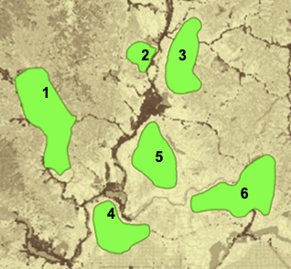
Cores

Resistances:

Low

Medium

High
Demo data viewed in LM_Demo.mxd.

1) Place the demo directory somewhere easy to browse to with no spaces or special characters in the directory name (e.g., C:\LinkageMapper\demo). Your project directory for the tutorial will be demo\output\lm.
2) Open LM Demo.mxd in ArcMap or in ArcGIS Pro the LM Demo map in ArcGIS Pro Demo.aprx.
3) Open the Linkage Mapper Toolbox, and click on Build Network and Map Linkages. The following dialog will appear in ArcGIS Desktop:

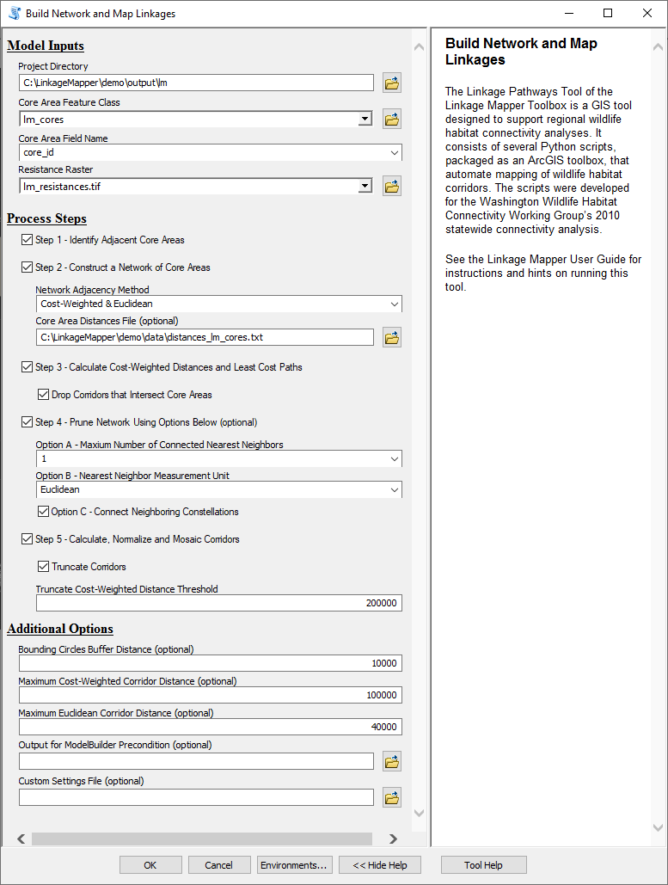
A
B
C
D
E
F
G

4) Enter the following (refer to letters in dialog image above):
- Input Data
Project Directory: Browse to where you placed the demo directory and select the output/lm directory within it.
Core Area Feature Class: choose lm_cores
Core Area Field Name: choose core_id
Resistance Raster: choose lm_resistances
- Check all the steps.
- Step 2 - Construct a Network of Core Areas
Core Area Distances Text File: Browse to where you placed the demo directory and open the data directory within it. Choose distances_cores.txt (If you are using ArcGIS Desktop Advanced or ArcGIS Pro you can leave this field blank, it will generate a distance file and place it in your project directory).
Network Adjacency Method: Choose Cost-Weighted & Euclidean.
- Step 3 - Calculate Cost-Weighted Distances and Least-Cost Paths
Drop Corridors that Intersect Core Areas: Check this box.
- Step 4 - Prune Network
Number of Connected Nearest Neighbors: Choose 1.
Nearest Neighbor Measurement Unit: Choose Euclidean distance.
Connect Neighboring Constellations: Check this box.
- Step 5 - Calculate least-cost corridors and mosaic them into a single map
Truncate Corridors: Check this box.
Truncate Cost-Weighted Distance Threshold: Enter 200000.
- Additional Options:
Bounding Circles buffer Distance (optional): Enter 10000 (equal to 10km).
Maximum Cost-Weighted Corridor Distance: Enter 100000 (equal to 100 km).
Maximum Euclidean Corridor Distance: Enter 40000 (equal to 40km).
Click OK. You can view outputs in LM Demo Results.mxd in ArcMap or the LM Results map in ArcGIS Pro project
Warning: Some installations of ArcMap have a difficult time overwriting all the Linkage Pathways outputs when running the model again in the same project directory. In such cases, use ArcCatalog, or make a new subdirectory for each run.

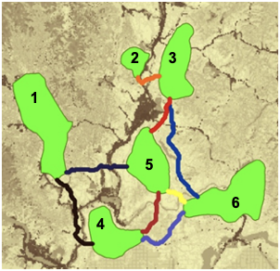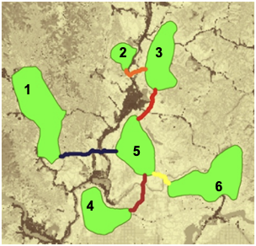
Above left is the network showing active links after step 3 using the settings above (intermediate shapefile outputs are stored in the run_history directory). Yellow corridors have the lowest cost-weighted distances, and black corridors have the longest. Note that the corridor between cores 1 and 2 has been dropped because it is too long (118 km in cost-weighted distance units). The reason links have been dropped can be determined by querying the stick or lcp shapefiles. Above right is the network after running step 4. Each core area is connected to its nearest neighbor, and the link between cores 3 and 5 connects two otherwise disjunct constellations of core areas.
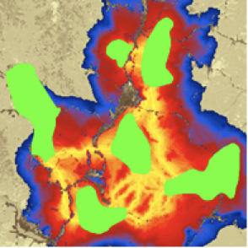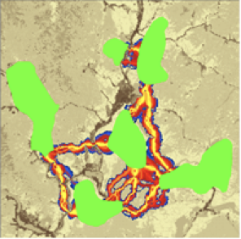
Left: normalized and mosaicked least-cost corridors (lm_corridors in corridors.gdb) produced by the settings above. Only values from 0 to 100,000 are shown. Right: corridors clipped to 5km cost-weighted ‘width’ cutoff using the Clip Corridors to Cutoff Width tool in the Linkage Mapper Utilities toolset. See Chapter 2 of WHCWG (2010) for description of linkage width cutoffs.

